hospital management system
final project for sql module by saikeella


- Introduction
A Hospital Management System is a software that helps hospitals manage patient appointments, records, payments, and doctor schedules efficiently.
This database contain 5 tables:
- Patient
- Doctor
- Appointment
- medical_histroy
- payment
How these tables/entities are related to each other is shown pictorialy througth
ER-diagram.

TABLES
- patient: Patients use hospital services to receive medical care, treatment, and support for their health needs.
- doctor: Doctors in hospitals use Hospital Management Systems to schedule appointments, access patient records.
- appointment: The appointment uses in a hospital management system allows patients to schedule meetings with doctors for medical treatments.
- medical records: The medical records system in a hospital maintains detailed information of patients health information and treatment history.
- payment: Payment management in hospitals billing for medical services provided to patients.

entities
1.patient: Attributes includes patient ,patient_id(PK) , first_name ,last_name,
date of birth, address and reason.
2.doctor: Attributes include doctor ,doctor_id(PK) ,first_name,last_name.
3.Appointment: Attributes include appointment ,appointment_id(PK),
patient_id(FK) ,doctor_id(FK), Appointment_date , Appointment_time
and status.
4.medical records: Attributes include medical records ,medical_id(PK) ,
patient_id(FK), diagnosis_date and treatment.
5.payment: Attributes include payment , payment_id(PK), patient_id(FK),
and medical fees.

2.ER-DIAGRAM FOR HOSPITAL MANAGEMENT SYSTEM:
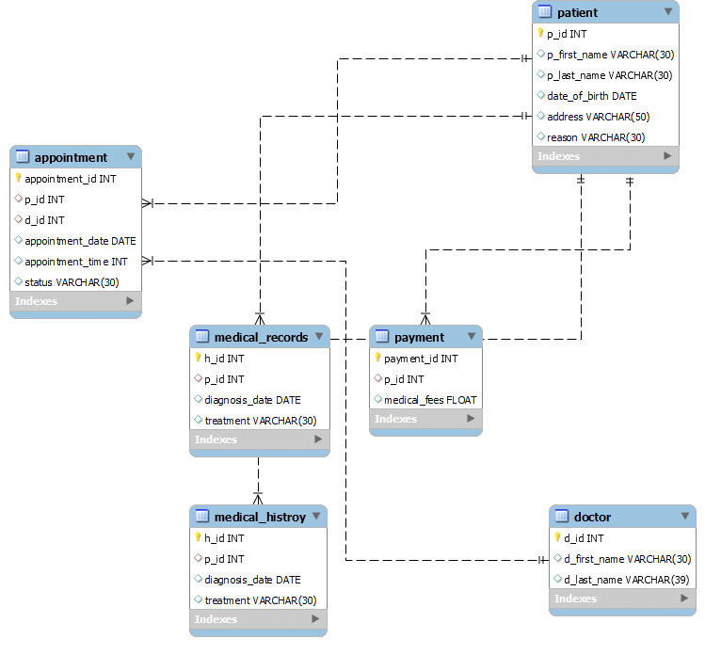

description tables:

A)describe patient:
field | type | null | primary key | default
p_id | int | no | primary key | null
p_first_name | varchar(30) | yes |  | null
p_last_name | varchar(30) | yes |  | null
date_of_birth | date | yes |  | null
address | varchar(30) | yes |  | null
reason | varchar(30) | yes |  | null

B)describe doctor:
field | type | null | key | default
d_id | int | no | primary key | null
d_first_name | varchar(30) | yes |  | null
d_last_name | varchar(30) | yes |  | null
C)DESCRIBE APPOINTMENT:
field | type | null | key | defaut
appointment_id | int | no | primary key | null
p_id | int | yes | multivalued | null
d_id | int | yes | multivalued | null
appointment_date | date | yes |  | null
appointment_time | int | yes |  | null
status | varchar(30) | yes |  | null
D)DESCRIBE MEDICAL_HISTROY:
field | type | null | key | defaut | EXTRA
H_ID | int | no | primary key | null | AUTO_INCREMENT
p_id | int | yes | multivalued | null
diagnosis_date | date | yes |  | null
treatment | varchar(30) | yes |  | null
E)DESCRIBE PAYMENT:
field | type | null | key | defaut | EXTRA
payment_id | int | no | primary key | null | AUTO_INCREMENT
p_id | int | yes | multivalued | null
medical_fees | float | yes |  | null

4. COMMANDS:
A)create database;
create database hospitality;
B)select database;
use hospitality;
C)create table named patient:
create table patient(
p_id int primary key,
p_first_name varchar(30),
p_last_name varchar(30),
date_of_birth date ,
address varchar(50),
reason varchar(30)
);
insert into patient (p_id,p_first_name,p_last_name,date_of_birth,address,reason)
values(1,"sai","keella","2004-04-11","mankoli","fever"),
(2,"rohit","zanjuri","2001-09-12","majiwada","back pain"),
(3,"sagar","bheemA","2004-07-11","HYDERBAD","fever"),
(4,"manoj","kalke","2001-03-17","besi","leg injury"),
(5,"raju","kumar","1994-09-18","sasanam","dengue"),
(6,"ramu","sunadram","2007-04-21","gokanapuram","diabitie"),
(7,"prem","kumar","2006-11-01","makanpuram","back pain"),
(8,"joga","pitta","2009-09-17","sasanam","fever"),
(9,"manikanta","tekala","2004-08-21","ramachandrapuram","heart disease"),
(10,"praveen","anishetti","2009-08-01","guntur","cancer") );

- select * from patient;

D)create table named doctor:
create table doctor(
d_id int primary key,
d_first_name varchar(30),
d_last_name varchar(39)
);
insert into doctor(d_id,d_first_name,d_last_name)values
(1,"sunil","reddy"),
(2,"siddu","anisetti"),
(3,"susma","amboti"),
(4,"hansi","malapada"),
(5,"harsh","vardana"),
(6,"madhav","reddy"),
(7,"usha","ranide"),
(8,"hema","chikala"),
(9,"sruthi","anisetti"),
(10,"rakesh","buddana") );

- select * from doctor;

E)create table appointment:
create table appointment(
appointment_id int primary key auto_increment,
p_id int,
d_id int,
appointment_date date,
appointment_time int,
status varchar(30),
foreign key(p_id)references patient(p_id),
foreign key(d_id)references doctor(d_id)
);
insert into appointment (p_id,d_id,appointment_date,appointment_time,status) values
(1,3,7,"2024-09-11","11.30","confirmed"),
(2,7,6,"2024-09-11","12.00","confirmed"),
(3,4,8,"2024-09-12","12.00","pending"),
(4,5,9,"2024-09-15","11.00","pending"),
(5,6,3,"2024-09-18","10.30","pending"),
(6,8,4,"2024-09-19","12.30","pending"),
(7,,1,"2024-09-24","11.00","confirmed"),
(8,1,"2024-09-26","12.00","pending")
(9,6,"2024-09-11","11.00","confirmed") );

- select * from appointment;

F)create table medical_histroy:
create table medical_histroy(
h_id int primary key auto_increment,
p_id int,
diagnosis_date date,
treatment varchar(30),
foreign key(p_id) references patient(p_id)
);

insert into medical_histroy(p_id,diagnosis_date,treatment) values(1,"2004-04-12","fever"),
(2,"2001-09-13","back pain"),
(3,"2004-07-12","fever"),
(4,"2001-03-18","leg injury"),
(5,"1994-09-19","dengue"),
(6,"2007-04-22","diabitie"),
(7,"2006-11-02","back pain"),
(8,"2009-09-18","fever"),
(9,"2004-08-22","heart disease"),
(10,"2009-08-02","cancer") );

- select * from medical_histroy;

G)create table named payment:
create table payment(
payment_id int primary key auto_increment,
p_id int,
medical_fees float,
foreign key(p_id) references patient(p_id)
);
insert into payment(p_id,medical_fees) values
(1,"4500.00"),
(2,"500.00"),
(3,"450.00"),
(4,"5400.00"),
(5,"6700.00"),
(6,"8700.00"),
(7,"900.00"),
(8,"1200.00"),
(9,"1350.00"),
(10,"6750.00")
);
- select * from payment:

- select medical_histroy who has done medical check or patient and doctor details?
select * from medical_histroy as m left join patient on
m.h_id=patient.p_id;

select treatment,p_first_name,p_last_name from
medical_histroy as m inner join patient on
m.h_id=patient.p_id;
2. select payment details of all who made the payment and
completed the payment?
select p_first_name,p_last_name,address,medical_fees from
payment inner join patient on
payment.payment_id=patient.p_id;

3.who is the patient came to the doctor,their names and doctors names?
select p_first_name,p_last_name,d_name from doctor left join patient on doctor.d_id=patient.p_id;

4.display list of top 10 members appointment shown who's status confirmed or not ?

select p_first_name,p_last_name,status appointment inner
join patient appointment.appointment_id=patient.p_id?

